Product Catalog | Battery Base
Connector Type | Battery Connector
Applicable Battery Specification | CR1220
Operating Temperature Range | -
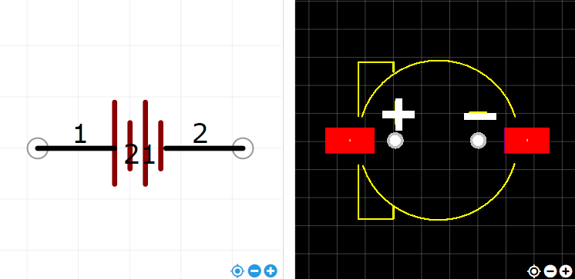
https://item.szlcsc.com/71476.html

